Ni- 50% Al Lattice Model Attachments

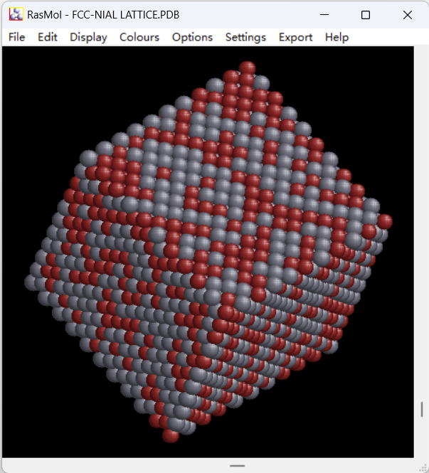

Al Atom

Ni Atom

Lattice Structure rendered by RasMol （Assuming 10 lattices in a single direction）

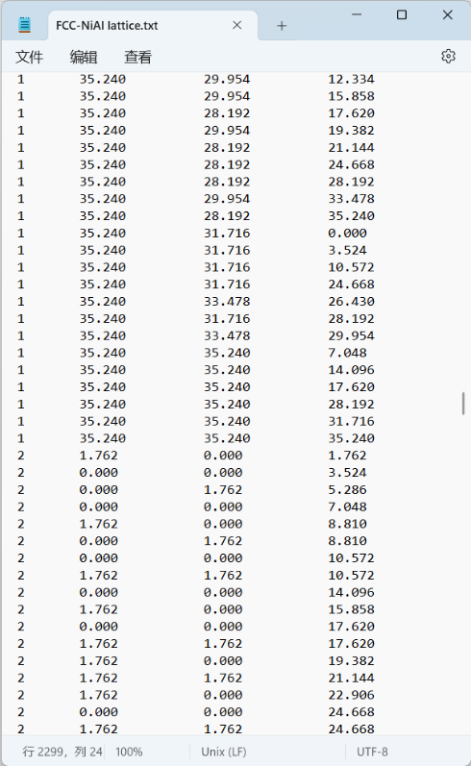

Output data with txt format (Label 1 for Ni and 2 for Al)